SIT725 – Applied Software Engineering

Jae Doyne

ID: 220287173

**Software Requirement Specification**

Project Title:

“Good Extracts”

Key Research Theme

(Environment and Sustainability)

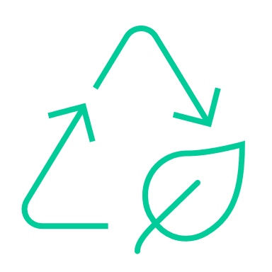

# Contents

Overview – Problem to Solve 3

Key Goals for the Project 4

Market Research 5

Target Market, Story, Voice 6

Summary - Functional Requirements 7

Key Non-Functional Requirements 8

User Stories 9

Further functionality or different app entirely 11

Key Terms and Rules 12

Project Technologies and Data 13

Proposed Site Map 14

Key Pages Wireframing 15

Class Diagram 16

Database Design 17

# Problem Statement

If consumers want something, they often choose to buy new, instead of sourcing a ‘used’ item that still holds value. As a result, they maintain a stock of under-utilised goods which sit idle or are prematurely dumped to make way for more new things. This behaviour contributes to environmental degradation and sickness, as manufacturing and waste disposal processes are significant sources of industrial pollution.

Unfortunately, buying new goods is often easier, less uncertain and satisfies the human craving for ‘new’. It can be difficult to easily source suitable used goods or offer unwanted/under-used goods to others effectively.

By making it easier to source used goods from peers and removing friction from exchange interactions, I hope to help reduce excessive new good purchasing.

Importance

The reduction of new goods purchased will translate into less industrial pollution, less rubbish going into landfill and oceans, less pollution-related human disease, slow the depletion of natural resources and reduce carbon emissions. This in turn will lead to a cleaner, happier and more sustainable life on this planet for all humans.

Market Research

There are several platforms that attempt to connect peers for the purpose of sourcing and offering ‘used’ goods on either a temporary or permanent basis, either in exchange for something or given away for free.

Those that are not money based include [OLIO](https://olioex.com/), [Street Bank](https://www.streetbank.com/splash?locale=en), [BarterQuest.com](http://www.barterquest.com/) and [Freecycle.org](https://www.freecycle.org/).

* OLIO focusses on neighbors and local businesses sharing food,
* Freecycle is a gifting platform that requires access to private groups,
* BarterQuest attempts to ‘match’ user offers and ‘wants’
* StreetBank attempts to connect groups based on a 1-mile radius around their home.

Others that are money based include [Facebook Marketplace](https://www.facebook.com/marketplace), [Craigslist](https://melbourne.craigslist.org/) and [Gumtree](https://www.gumtree.com.au/).

# Overview – Problem to Solve

This document is a plan to build a web application that primarily enables users to barter for and share goods and services within their local community over the internet.

The app seeks to:

* Increase:
  + Recycling of existing goods
  + Sharing of existing goods
  + Upcycling of existing goods,
  + Production of new goods from the home,
  + Composting items
  + Reduction of needed items
  + Refusal of unneeded items
  + Understanding of sustainable living practices

In an effort to:

* reduce transit distance between good exchanges
* reduce carbon emissions and environment concerns associated with manufacturing new items and disposing of used items
* Filling and upskilling local service gaps,
* Increasing individual sustainability practices,
* Increasing community connectivity and,
* Providing people with a means to increase their productivity and sense of purpose.

The following key pain points have been identified as relevant to many people today.

1. People feel disconnected from others/their community, and crave interaction/connection to a particular group or ‘tribe’
2. People are concerned about the environment and capital consumption, and want to reduce their carbon footprint and pursuit of materialism
3. People have ‘things’ lying around their houses that they don’t need or use that could be swapped for something else or given away freely
4. People lack avenues to increase their purpose/sense of use and would relish the opportunity to contribute more meaningfully
5. People are interested in pursuing ‘mini-entrepreneurship’ from their homes and increasing the productivity of their home and land, and sharing this with the community

# Key Goals for the Project

What I aim to achieve by completing this project:

* **Complex web app that can be shown to prospective employers.**

I want the web app to demonstrate:

* Good use of HTML, CSS and JavaScript
* Base knowledge of React components
* Connected MySQL database, with good database design (3NF)
* Use of an Express NodeJS server with RESTful end points, authentication, validation, segregation of views and data, database control
* Use of MVC architecture
* Clean and well written code with commenting
* Understanding of running tests and debugging
* Using Git and Jira
* Updating the READ.ME

Implementation Roadmap

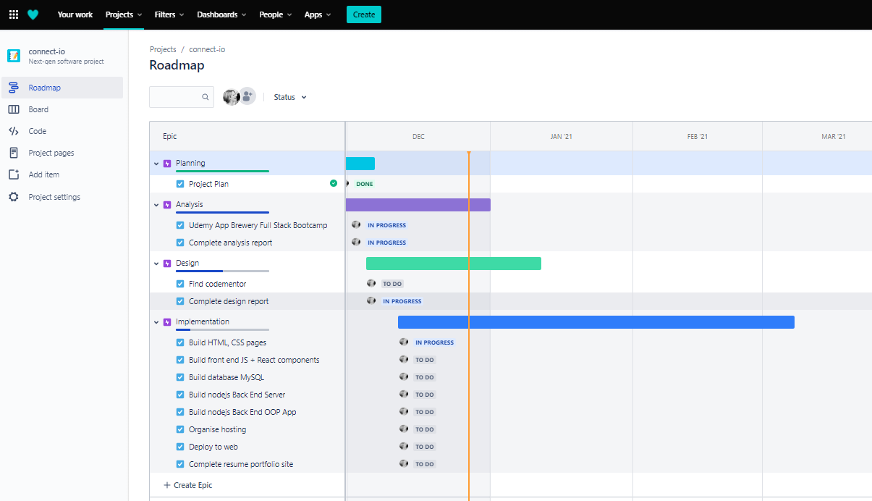

# Market Research

Also – what do they do wrong? What do they do right?

LiveLoveRecycle

OLIO

<https://www.streetbank.com/funding?locale=en>

* Freecycle
* Etsy
* <https://swapmeet.net.au/>
* <https://www.sellbuyswap.com.au/>
* Facebook marketplace
* Gumtree swap
* Craigslist

<https://www.savethestudent.org/shopping/top-five-swapping-websites.html>

<https://www.choice.com.au/shopping/online-shopping/selling-online/articles/online-sharing-platforms>

<https://communityexchange.net.au/terms.asp?xid=wwll>

<https://www.timebanking.com.au/> - services swap

https://au.ziilch.com/

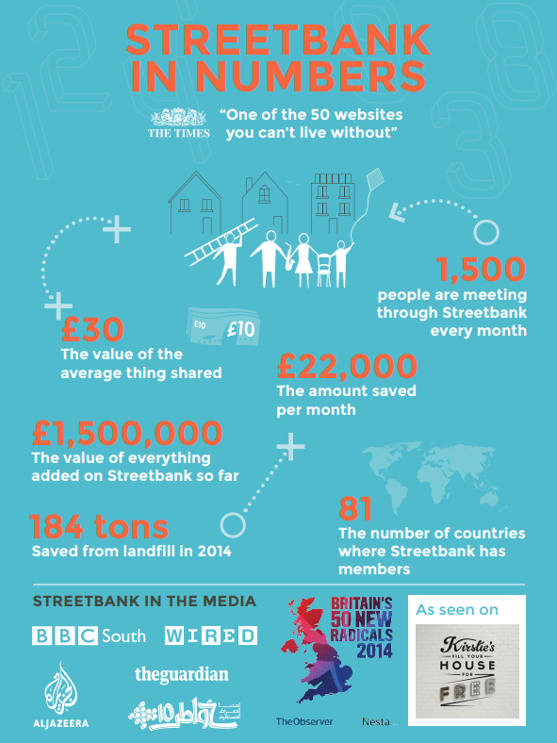

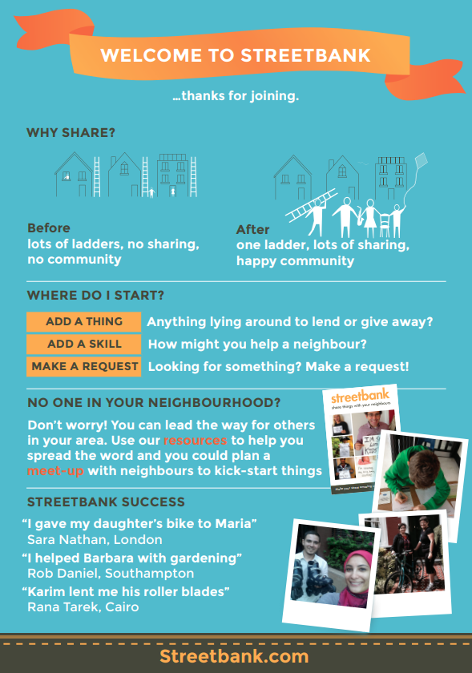

# Target Market, Story, Voice

The ideal user is:

* Socially and environmentally conscious, cultivating compassion and gratitude, connecting with community
* Interested in permaculture, upcycling household items, circular economics
* Looking to upskill, industrious, improve household productivity
* Retirees looking to help out, younger volunteers

Feelings to Inspire

* Turn yourself or your family unit into a business
* Reconnect with your community
* Feel good by helping others
* Feel good by recycling items rather than buying new
* Feel good by acquiring items locally rather than from afar
* Feel good by improving your productivity, skill set
* Feel good by feeling useful
* Reduce your carbon footprint
* Feel like you are part of a local ‘tribe’
* Demonstrate and gain recognition for your individuality from your community
* Feel safe and secure
* Not about ‘swapping stuff’, but about creating and developing a persona and hub of useful activity/production that benefits you and your community
* Focus has to be on the user/user’s family and community, not on the stuff
* Make it safe to use and exchange goods + services
* Don’t want to be seen as just shifting around crappy stuff
* Make it welcoming and not judgmental

# Summary - Functional Requirements

Core Functionality:

* **Create a private, secure account** with username and password
* **Build a personal profile** with a bio, pictures, preferences, stories etc.
* **Connect with three groups of other users** – your neighbors within 2km, local suburb (postcode based) and friends and family external to the first two
* **Create good or service (GOS) ‘offerings’** of items you are willing to either exchange for a ‘consideration’ (i.e. another GOS ) or give away for free – and make these offerings visible to your choice of connection group (neighbors, externals and/or suburb)
* **Create specific GOS ‘considerations’** of GOS items you and/or your family need, make these visible on your profile to connection groups
* **Initiate and manage manual GOS ‘exchanges’** by enabling a user to click on another user’s offering
* **Search for GOS listings** amongst your neighbors, wider community, friends and family

Additional Functionality

* **Choose what your profile looks like** depending on who is viewing – a neighbor, a suburb community member or external – or show the same for all
* **Initiate and manage auto GOS ‘exchanges’** by recognising when a user registers a particular consideration that matches the listing of another user, and suggest an exchange via notifications
* **Send and receive messages** to and from your various connections
* **Share an item** with your neighbors – can I borrow your….?
* **View your custom neighborhood page** with your neighbors, their listings + considerations, notice board and associated metrics
* **View your custom local suburb page** with your wider community, their listings + considerations, notice board
* **Post a notice** to your neighborhood page, your suburb page and/or externals page
* **Share stories with pictures** of recycling, upcycling, rotting with your connections, mini blog with selected audience then share more widely if you feel comfortable
* **Explore and share stories** from other communities

# Key Non-Functional Requirements

* No money involved
* Must enter home address to be connected
* Do not show home address to contacts
* Upon signing and entering address, immediately create/add to three groups:
  + Your neighbors i.e., everyone using the service within a 2km radius
  + Your local community i.e., everyone in your suburb
  + Your custom connections i.e., anyone you add yourself from your neighbors, community or external (e.g., friends and family outside your two radiuses)
* Auto see everyone in your neighborhood and community, but must add anyone external manually
* Exchanges to be managed online but executed offline in a secure place
* Groups can be created by churches, kindergartens, clubs, businesses etc.
* Users can ‘like’ particular items to indicate interest
* Referrals between groups – if someone you know in one group needs something that someone in another group has
* Matching –
  + when you list something you have, the system suggests potential matches
  + when you want something, the system suggests potential matches
* Local restaurants can create groups and be connected with locals or donate groups

WhatsApp

Meetup

Bumble

Airbnb

Craigslist

Issues that are solved by this:

* Safety, privacy, trust – uses existing social networks
* Categorisation
* Simplifies
* Makes people feel good about themselves
* Connects others (particularly neighborhoods)

# User Stories

1. Create an account
   * Create and update username and password
   * Ensure usernames are unique, passwords are strong
   * Require home address
   * Save information in database and authenticate upon login
   * Change password
   * Delete account
   * Go to dashboard once account is set up
2. View initial dashboard
   * View notifications (new offerings, exchange updates, new connections, stories)
   * Update profile
   * Go to offerings and considerations
   * Go to exchange centre
   * View connections and groups
   * View community page
   * View neighbor page
   * Go to search listings
   * Overall search box

1. Build out your profile
   * Enter from dashboard
   * Start with a basic page
   * Add a profile picture
   * Add a bio tag line
   * Add household details
   * Add general offerings and considerations up for swap
   * Include general skill offerings like flat packing, cooking, cleaning etc.
2. Connect with others
   * Enter from dashboard
   * View existing connections and groups
   * Search for connections
   * Add connection to a group
   * Delete connection
3. Search for GOS listings
   * Enter from dashboard
   * View all listings
   * Filter listings – by group, date added, type
   * Open a listing
   * Begin an exchange for a listing
   * Close a listing
4. Manage a GOS offering
   * Enter from dashboard
   * View existing GOS offerings and status
   * Add new GOS offering
     + Description
     + Type
     + Free or for exchange
     + For all or restricted group
     + Status
     + Date added
     + Possible considerations
   * Update GOS offering
   * Delete GOS offering
5. Manage a specific GOS consideration
   * Enter from dashboard
   * View existing GOS consideration and status
   * Add new GOS consideration
     + Description
     + Type
     + Free or for exchange
     + For all or restricted
     + Status
     + Date added
     + Possible offerings
   * Update GOS consideration
   * Delete GOS consideration
6. Manage a GOS exchange
   * Enter from offering
   * Make an offer as a suggester to exchange a GOS listing
   * Receive a response from the lister
   * Accept, suggest alternative exchange or reject the offer outright
   * Settle the exchange
   * Close off the exchange
   * View exchange history
7. Manage messages with connections
   * Enter message centre from dashboard
   * View inbox and new messages received
   * Create and send new message to one or many connections
   * Delete messages
   * Filter messages
   * View sent messages

# Further functionality or different app entirely

* **Set sustainability goals**, based on the Rs - get tips and reminders, see your progress
* **Gamify your sustainability goals** by unlocking sustainability achievements (including shares, giveaways and exchanges) and progressing up a sustainability ladder - see the progress on your profile, see how you compare to others/your neighborhood & community compare to others
* **Generate an automated sustainability level up plan based on user inputs**
* **Create a local event** and invite your neighbors
* **Create a community event** and invite connections from your suburb
* **Sustainable living practices blog with videos**

# Key Terms and Rules

**Offer Listing**

An offer listing or offering is either a good or service (GOS) that you are willing to either offer in exchange for another GOS or to give away for free.

**Consideration Listing**

A consideration is something you need or are willing to consider exchanging for something you have offered. A consideration can be specific to a particular GOS (which then appears on a user’s profile) whereas general considerations are a list of categories of items you would consider for an exchange – it’s then up to the ‘suggester’ to suggest a particular consideration.

**Exchange**

An exchange occurs where a user clicks on an offering listing and makes an initial offer in consideration for the item offer. The ‘offer lister’ is notified of the offer and is prompted to either accept, reject or suggest a different consideration. The ‘suggester’ in return either accepts, rejects or suggests a different consideration, and so on until a consensus is reached. If agreement is reached, the users agree on a method for exchange and make the exchange in the real world. Each user confirms the exchange which closes it. Both are prompted to review the exchange once it is complete.

**Neighborhood**

A radius of 2 kilometers around your house address.

**Local Community**

Your suburb + 2 kilometers around your house address.

**Network**

Your community connections + your external connections (friends and family outside your community geographical radius).

# Project Technologies and Data

* Front end – HTML, CSS, JS, React
* Back end – MySQL, NodeJS, ExpressJS, EJS
* Tools – Git
* Data – Location external APIs, own database

Front end

Back end

Database

Security

Frameworks

Tool set

Design principles

Data flow

**Architecture Diagram**

# Proposed Site Map

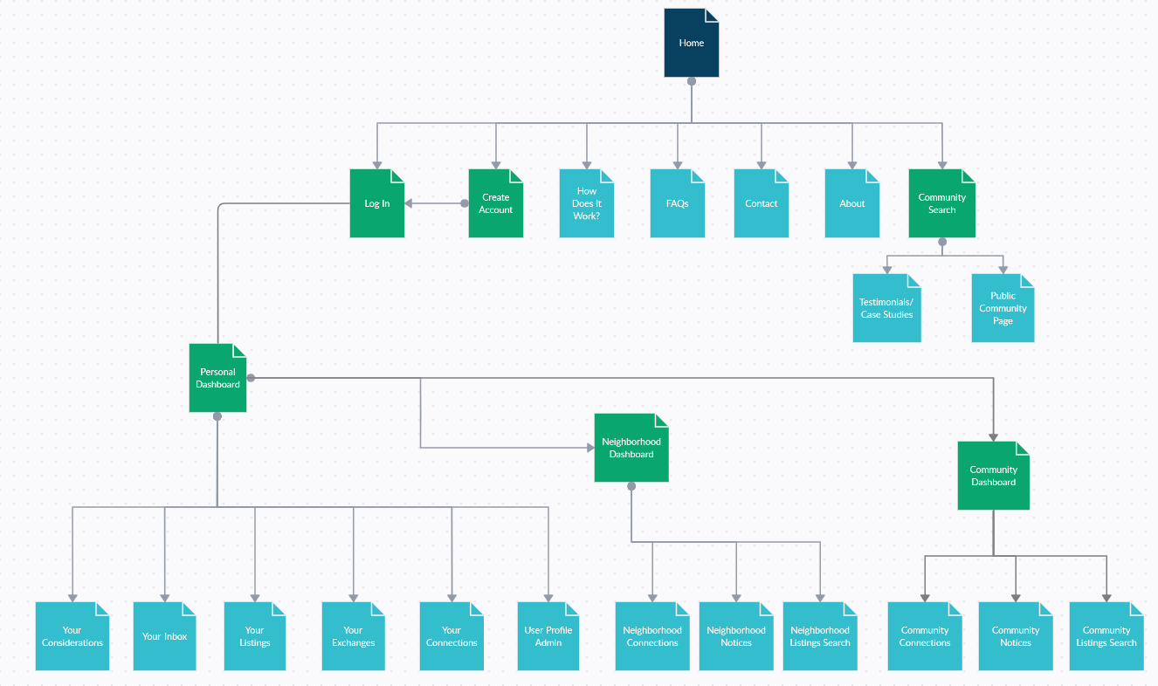

# 

# Key Pages Wireframing

# Class Diagram

# Database Design

Data Types and Inputs, Validation